END SEMESTER PROJECT REPORT

Project Name



Programming Fundamentals COMP 111
Programming Fundamentals Lab COMP 111L

SUBMITTED BY

Mohib Ali Khan | B24F0144DS016

SCHOOL OF COMPUTING SCIENCES
PAK-AUSTRIA FACHHOCHSCHULE: INSTITUTE OF APPLIED SCIENCES AND TECHNOLOGY (PAF-IAST), MANG, HARIPUR.

JANUARY 2025
Table of Contents
1 Problem Statement 3
2 Aims & Objectives 3
3 Literature Review 4
4 Methodology 4
4.1 Overview 4
4.2 Tools and Technologies 4
4.3 Implementation 4
4.4 Limitations 4
5 Final Outcomes 5
6 Conclusions 7

Problem Statement
Teachers face daily challenges in collecting, managing, and storing data efficiently. That’s why our team created the Teachers' Portal – a user-friendly website designed to simplify data management. With this platform, teachers can effortlessly organize, store, and access their data, empowering them to focus on what truly matters: teaching and shaping futures.

Aims & Objectives

- Streamline Administrative Processes: Develop a user-friendly platform to simplify and digitize teachers' administrative tasks.
- Enhance Accessibility: Provide teachers with a centralized portal to access their professional data and perform key functions.
- Promote Efficiency: Reduce manual workload by automating tasks such as attendance marking and result entry.
- Ensure Data Security and Reliability: Safeguard sensitive data like course details, attendance records, and exam results.
- Profile Management: Allow teachers to view and update their profiles with personal and professional information.
- Course Overview: Enable teachers to check assigned courses and related details in real-time.
- Attendance Management: Facilitate accurate and efficient marking of student attendance via the portal.
- Exam Result Entry: Provide tools for entering and managing exam results, with seamless storage in a secure database.
- Database Integration: Ensure all data is securely stored and retrieved using a robust backend database system.

Literature Review
Teacher portal websites help make a teacher's job easier by bringing all their important tasks into one place. These portals let teachers check their profiles, see their courses, mark attendance, and enter student exam results quickly. Research shows that using such portals saves time and reduces mistakes.
Good teacher portals are easy to use, even for people who are not very good with technology. They also keep data safe, so student and teacher information stay private. This project aims to create a simple and useful portal to help teachers do their work faster and better

Methodology

Overview
Teacher Portal website is a comprehensive platform designed for educators, enabling them to manage their teaching responsibilities efficiently. Teachers can access their profiles, view assigned courses, manage attendance records, and enter or update exam results seamlessly, all within a user-friendly interface.

Tools and Technologies
- HTML
- CSS
- Node JS
- Mongo DB
- Visual Studio Code

Implementation
- Make website structure by HTML.
- Design the structure using CSS.
- Make database with Mongo DB.
- Connect database with website by node js.

Limitations
Currently, our website is limited to following features
- View Profile
- Check Courses
- Mark attendance
- Enter exam results.

Final Outcomes
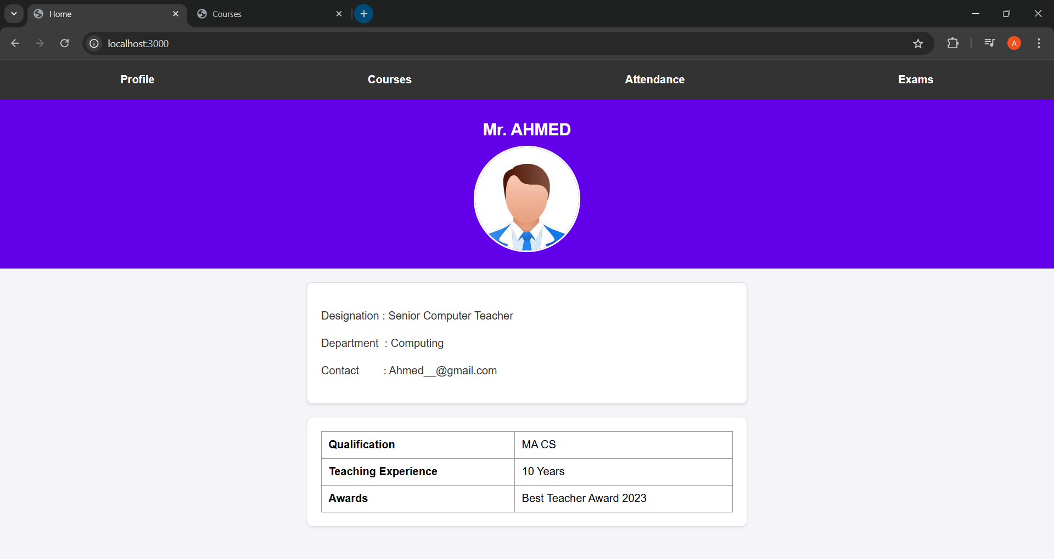

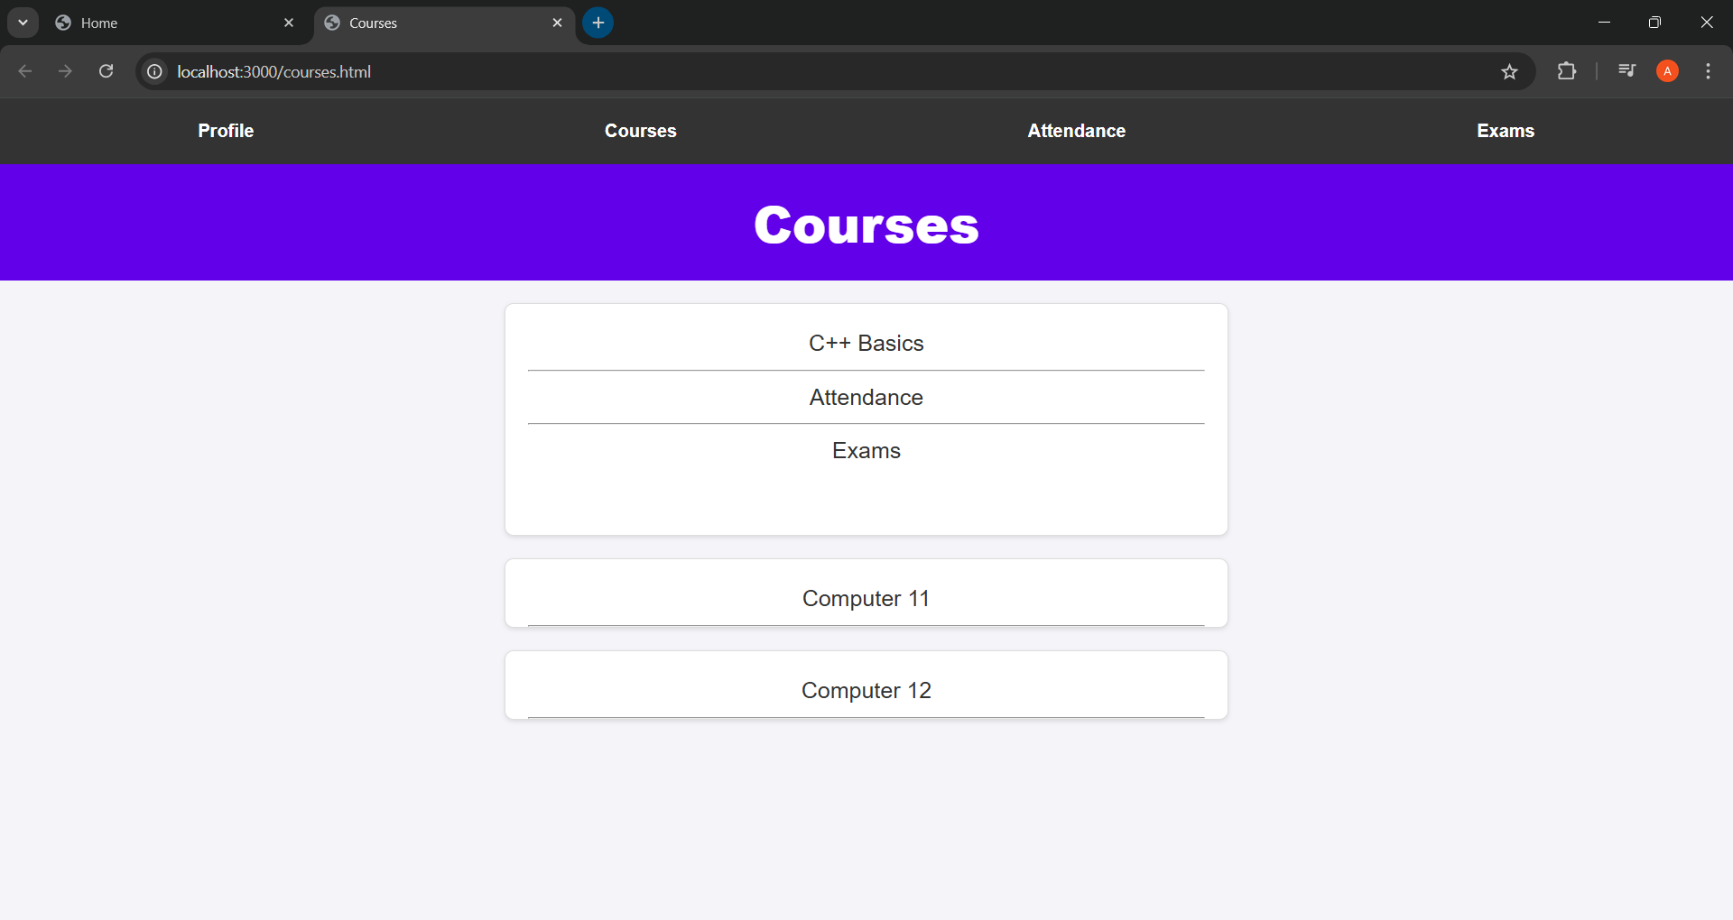
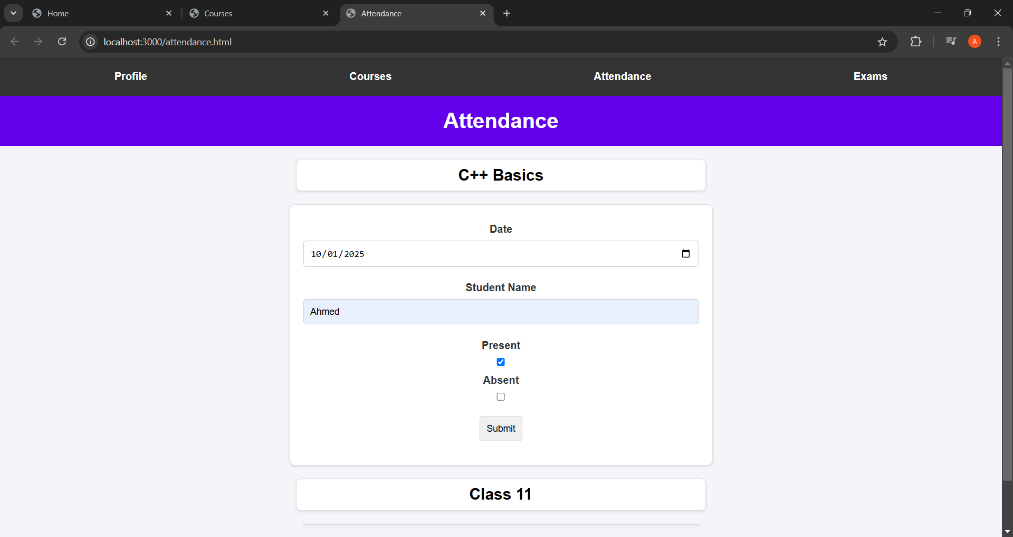

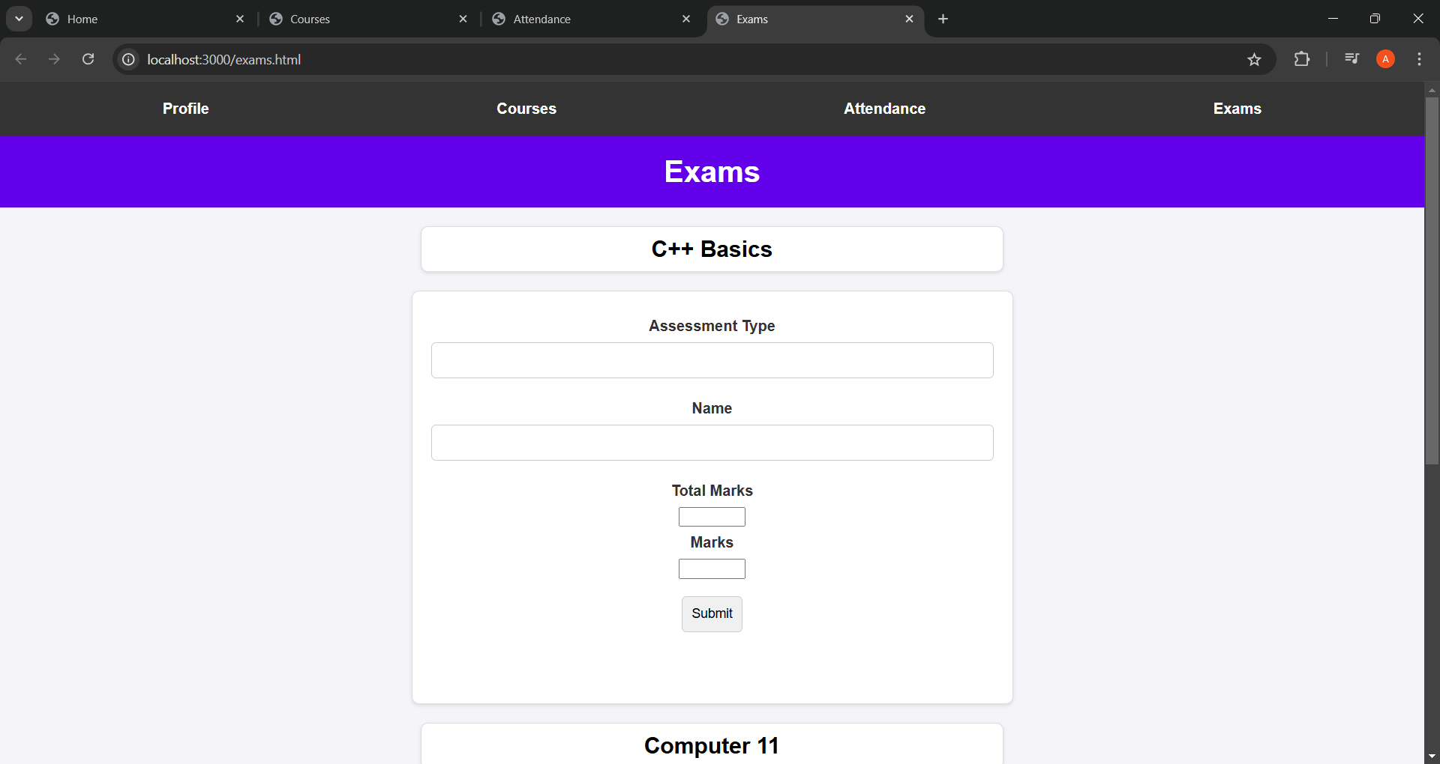
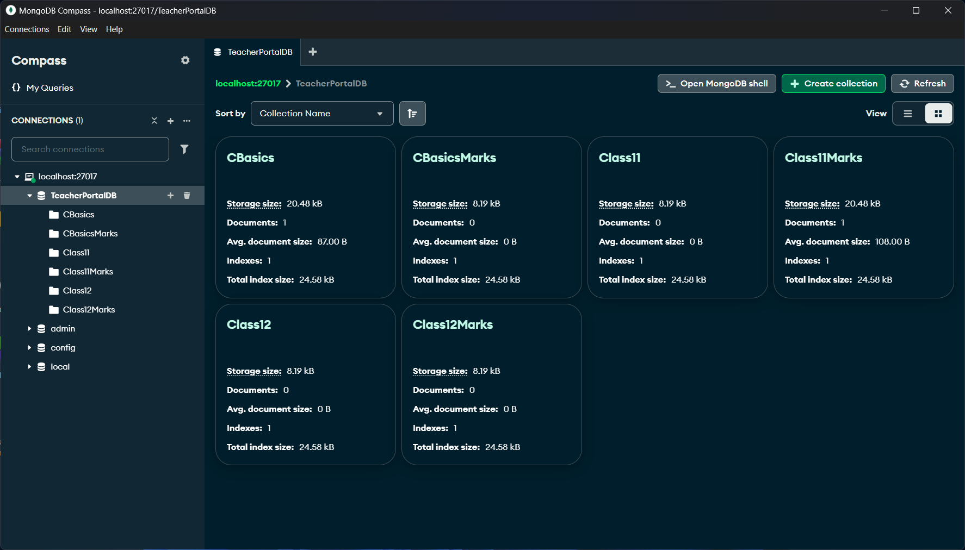

Conclusions
The teacher portal website is a user-friendly solution for managing academic tasks like viewing profiles, checking courses, marking attendance, and entering exam results. Built with Node.js and MongoDB, it ensures efficient, secure, and scalable data management. This project demonstrates the potential of modern web technologies to streamline educational workflows and improve overall efficiency.

